**Factory Design Pattern (Important)**

The Factory design pattern is a creational pattern that provides an interface for creating objects in a superclass, but allows subclasses to alter the type of objects that will be created. This pattern promotes loose coupling by eliminating the need to bind application-specific classes into the code.

**Definition**

The Factory pattern defines an interface for creating an object but allows subclasses to alter the type of objects that will be created. It provides a way to delegate the instantiation logic to subclasses, thereby promoting code reuse and flexibility.

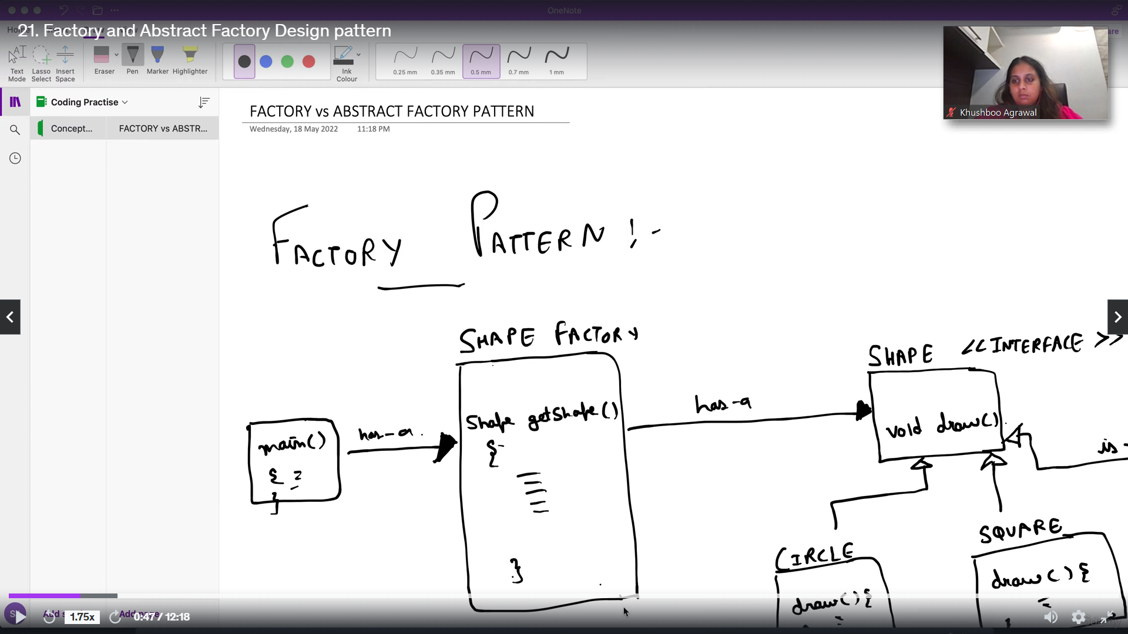

**Example**

Consider a scenario where we need to create different types of vehicles (e.g., Car, Truck).

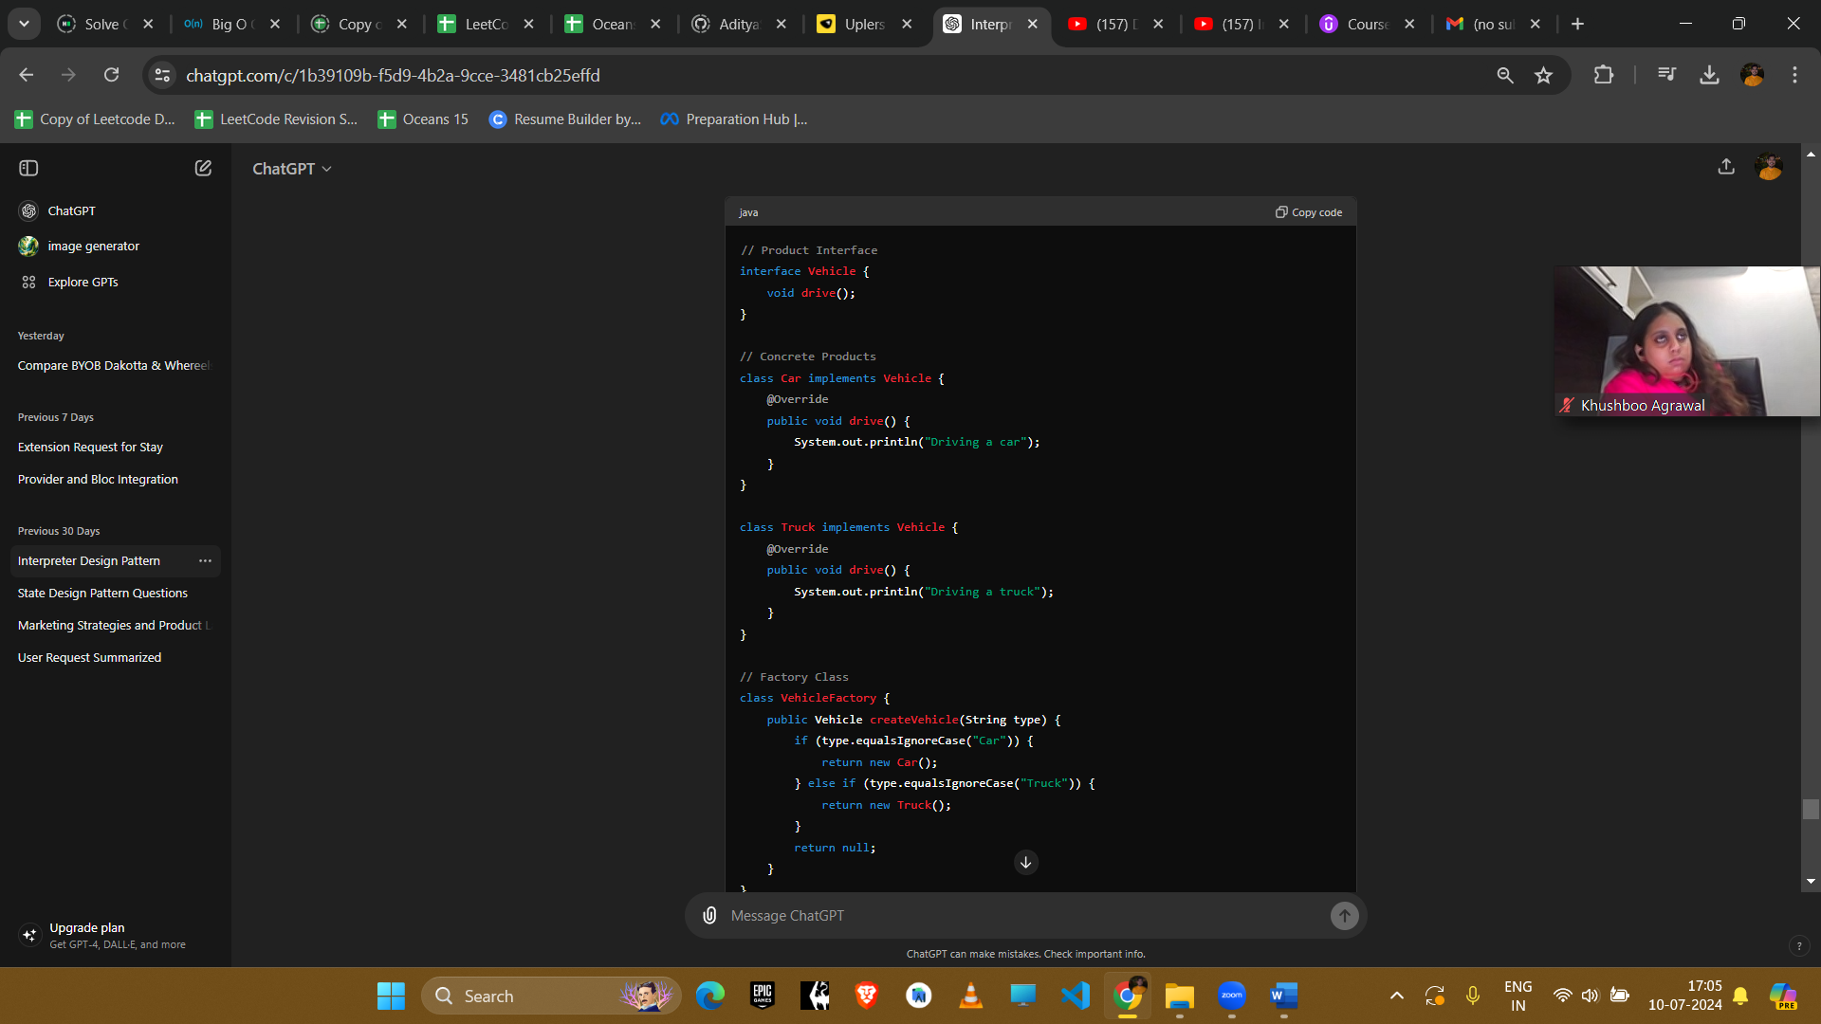

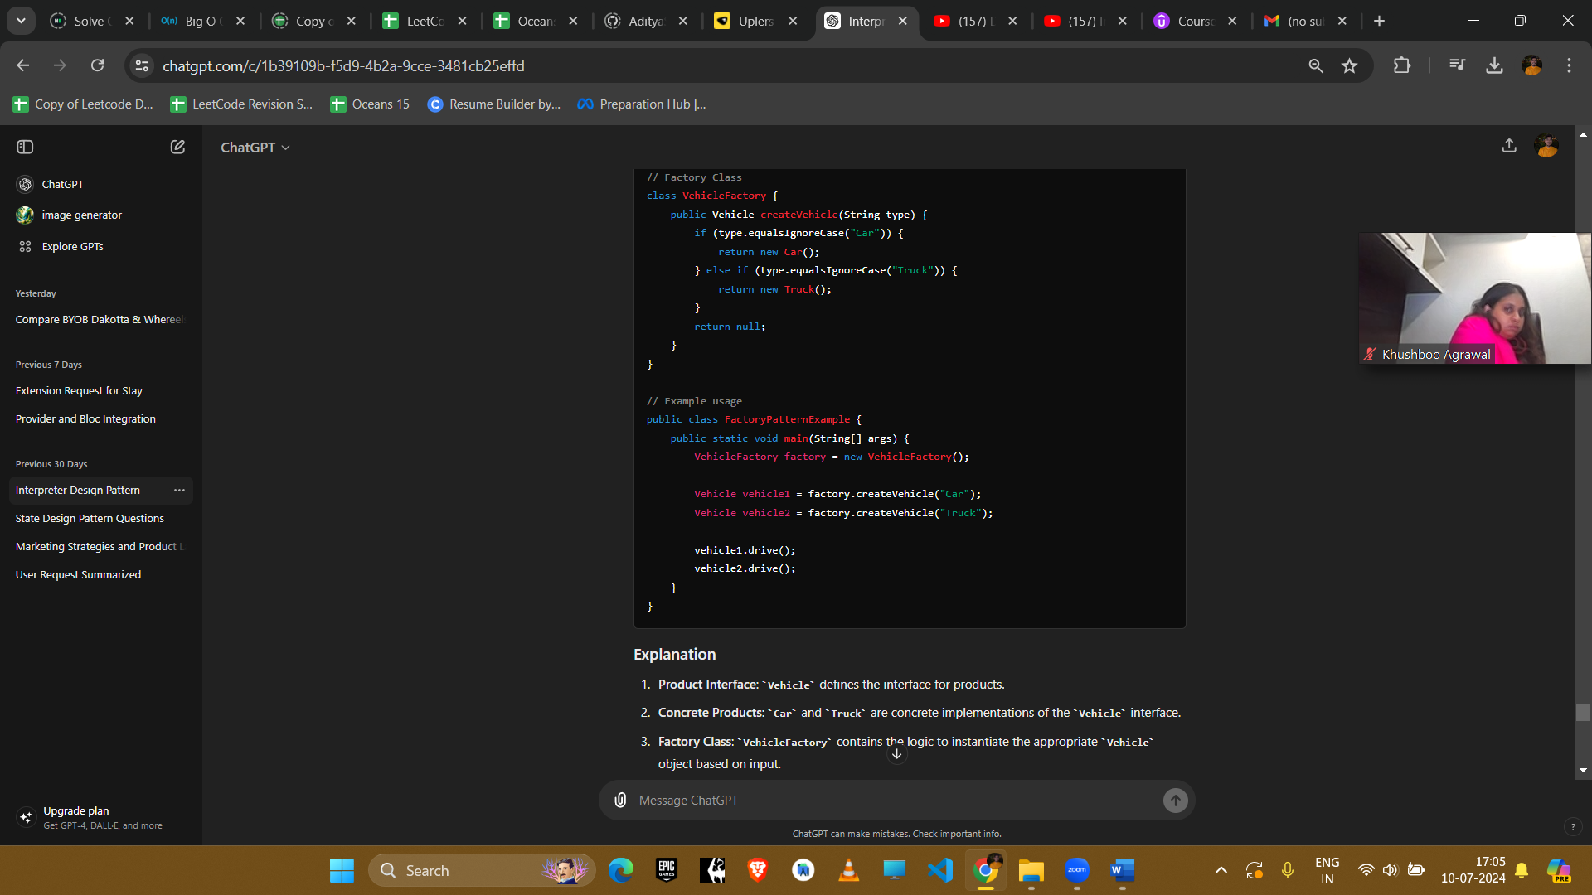

**Explanation**

1. **Product Interface**: Vehicle defines the interface for products.
2. **Concrete Products**: Car and Truck are concrete implementations of the Vehicle interface.
3. **Factory Class**: VehicleFactory contains the logic to instantiate the appropriate Vehicle object based on input.

**Example Uses in Amazon Interviews**

1. **Document Generation**
   * **Scenario**: Generating different types of documents (e.g., PDF, Word).
   * **Implementation**: Use a factory to create specific document types based on the input.
2. **Notification System**
   * **Scenario**: Sending different types of notifications (e.g., Email, SMS).
   * **Implementation**: Use a factory to create specific notification objects based on the notification type.

Explanation: <https://www.youtube.com/watch?v=7g9S371qzwM&list=PL6W8uoQQ2c61X_9e6Net0WdYZidm7zooW&index=7>

The Factory Pattern in Java is like ordering food from a menu at a restaurant. You tell the waiter what you want, and the kitchen prepares it for you.

In programming, it's used to create objects without exposing the instantiation logic to the client. Instead of directly calling the constructor of a class, you use a factory method to create objects based on certain conditions or parameters.

Use when:

* **Encapsulate Object Creation**: Use the Factory Pattern when you need to encapsulate the object creation process, hiding the details of instantiation from the client code.
* **Flexibility in Object Creation**: It's useful when you want to provide flexibility in creating different types of objects based on certain conditions or parameters.
* **Decouple Client and Concrete Classes**: Helps decouple client code from concrete classes, allowing for easier maintenance and future modifications.
* **Create Objects Dynamically**: Use it when you need to create objects dynamically at runtime, based on runtime conditions or configurations.
* **Centralized Object Creation Logic**: When you have complex object creation logic that you want to centralize in one place, the Factory Pattern can be a good choice.

### Abstract Factory Design Pattern(Factory of factory)

The Abstract Factory design pattern is a creational pattern that provides an interface for creating families of related or dependent objects without specifying their concrete classes. It allows the creation of objects that follow a general pattern, enabling the creation of related objects without knowing their specific classes.

Factory of factory.

The Abstract Factory Pattern in Java is like visiting a restaurant where you can order a set menu. You choose a menu, and then you receive a collection of dishes that belong to that menu.

In programming, it's used to create families of related or dependent objects without specifying their concrete classes. Instead of dealing with individual objects directly, you work with a factory that produces families of objects.

### Definition

The Abstract Factory pattern provides an interface for creating families of related or dependent objects without specifying their concrete classes. It is used to create a set of related objects without needing to specify their exact classes.

### Example

Consider a scenario where we need to create families of UI components (e.g., Buttons, Checkboxes) for different operating systems (e.g., Windows, Mac).

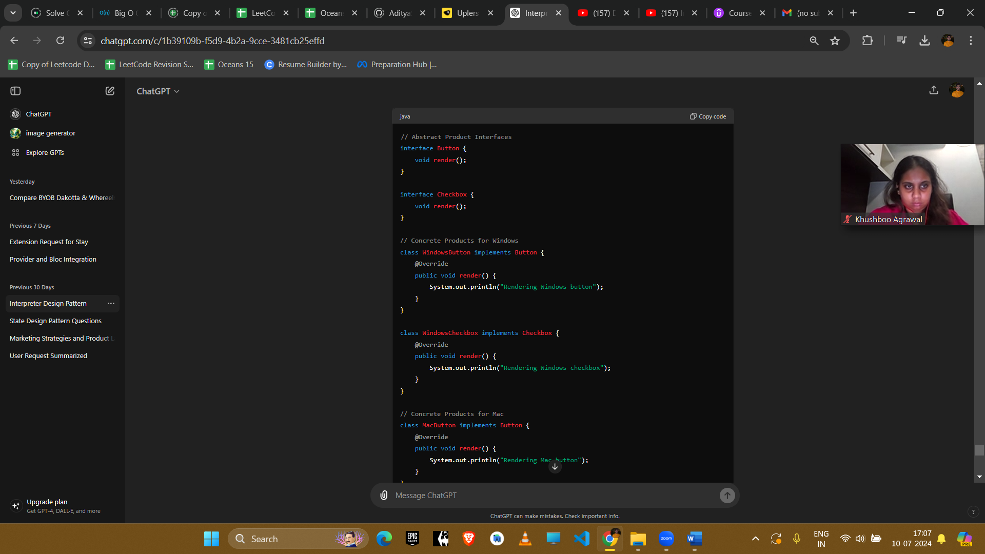

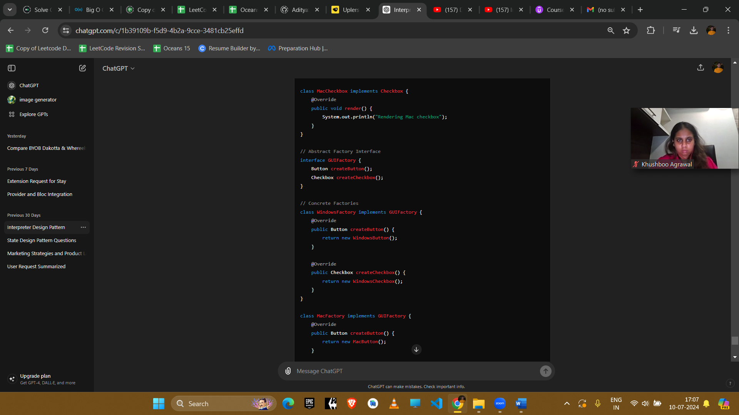

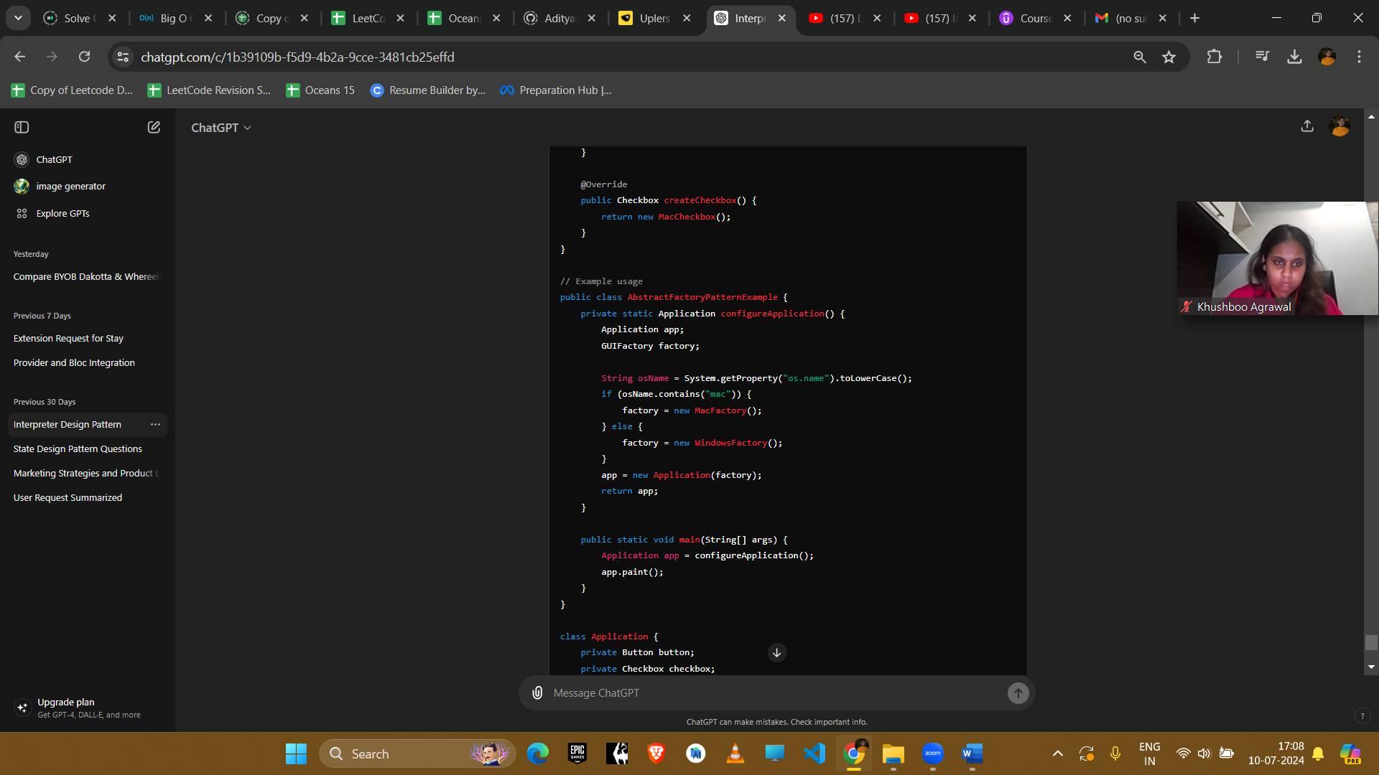

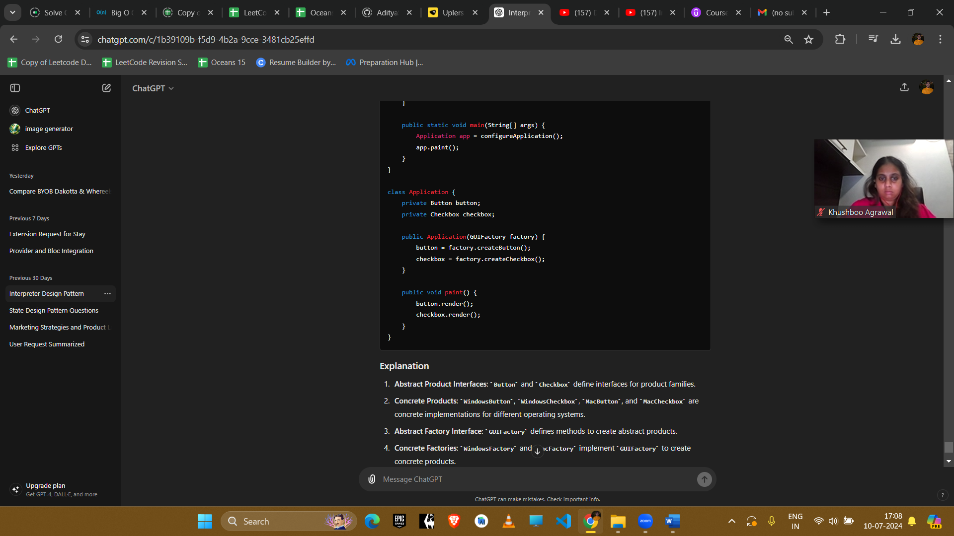

**Explanation**

1. **Abstract Product Interfaces**: Button and Checkbox define interfaces for product families.
2. **Concrete Products**: WindowsButton, WindowsCheckbox, MacButton, and MacCheckbox are concrete implementations for different operating systems.
3. **Abstract Factory Interface**: GUIFactory defines methods to create abstract products.
4. **Concrete Factories**: WindowsFactory and MacFactory implement GUIFactory to create concrete products.

**Example Uses in Amazon Interviews**

1. **Cross-Platform UI**
   * **Scenario**: Creating a cross-platform UI toolkit.
   * **Implementation**: Use an abstract factory to create platform-specific UI components, ensuring consistency across different platforms.
2. **Database Configuration**
   * **Scenario**: Configuring different database connections (e.g., MySQL, Oracle).
   * **Implementation**: Use an abstract factory to create database-specific connection objects, allowing the application to switch databases easily.

**Conclusion**

Both Factory and Abstract Factory patterns are creational patterns that help in object creation. The Factory pattern focuses on creating objects without specifying the exact class, promoting flexibility and reuse. The Abstract Factory pattern goes a step further by creating families of related objects, ensuring consistency and extensibility in complex systems. These patterns are valuable tools in designing flexible and scalable software systems.